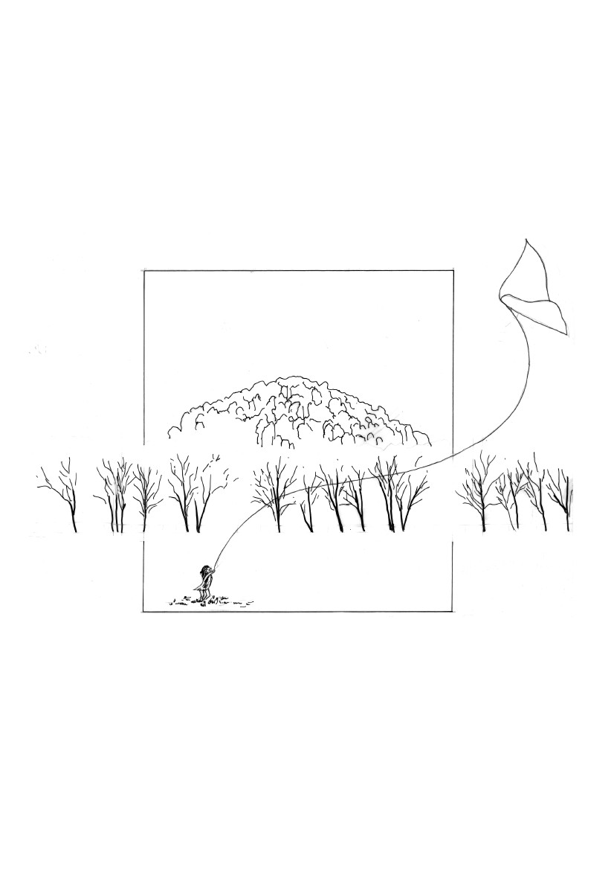
H
A
N
G
I
N
G
R O C K
RECREATION RESERVE
M A N A G E M E N T
P L A N
A Report to the Committee
of Management by the
LODER & BAYLY
Consulting Group
September 1993
CONTENTS
Page
Table of Contents
List of Figures
1.
2.
3.
4.
5.
6.
7.
8.
9.
10.
11.
12.
13.
14.
INTRODUCTION
LOCATION & CONTEXT
PHYSICAL DESCRIPTION
HISTORY
SITE ANALYSIS
OPPORTUNITIES AND CONSTRAINTS
VISITOR SURVEY
LANDSCAPE MANAGEMENT UNITS
ISSUES IDENTIFICATION
SITE ACCESS & CIRCULATION
REVENUE COLLECTION AND ACCESS
MANAGEMENT PLAN RECOMMENDATIONS
STAGING OF WORKS/PRIORITY OF ACTIONS
STANDARD DETAILS
3
5
10
12
15
20
25
31
34
41
43
61
63
i
ii
APPENDIX
FLORA AND FAUNA
REVENUE COLLECTION AND ACCESS
WEED CONTROL IN NATURAL BUSHLAND AREAS
CURRENT RESERVE REGULATIONS
CURRENT RESERVE FIRE MANAGEMENT PLAN
POSSIBLE RECREATIONAL/OPPORTUNITIES
VISITOR SURVEY FORM
REFERENCES
i
LIST OF FIGURES
Page
SITE LOCATION
REGIONAL CONTEXT
VEGETATION
VISUAL ANALYSIS
SITE OPPORTUNITIES
SITE ISSUES AND CONSTRAINTS
LANDSCAPE MANAGEMENT UNITS
EXISTING CIRCULATION AND PARKING
MAJOR EVENTS CARPARKING
ACCESS AND CIRCULATION
ROAD CLOSURE BEHIND RACE ENCLOSURE
SW. PICNIC AREA
EASTERN PICNIC AREA
RACE DAY VIEWING
ACCESS TO ROCK
MASTERPLAN
STANDARD DETAILS
2
4
8
14
18
19
29
33
34
35
36
37
38
39
40
44
from 63 onwards
ii

1.
INTRODUCTION
The Loder & Bayly Consulting Group were commissioned by the
Hanging Rock Recreation Reserve Committee of Management to
prepare a Landscape Management Plan for the Hanging Rock
Recreation Reserve.
The timing of this study is opportune, as it co-incides with the
realization of a long term goal of the Committee of Management to
purchase the adjacent property of 22 hectares to the east of the
Reserve and incorporate this land into the existing Hanging Rock
Recreation Reserve. The new land acquisition is a real asset, as it
facilitates the easier implementation of the main study goal as
recommended by the Land Conservation Council in its review of
District 1 of the Melbourne Area:-
" That the area continue to be used for the purposes approved by
Government following publication of the final recommendation for
the Melbourne area in 1977.
Notes:
1.
The existing recreation reserve, Parish of Newham,
encompasses Hanging Rock. The significant geological,
scenic, historical and floristic values of Hanging Rock
should be protected. "
It does this by allowing greater scopes for the dispersal of activities
which are currently concentrated close to the base of the rock,
exerting pressure on the values requiring protection.
In addition to the protection of natural values, major historical values
to be preserved are the bi-annual picnic race meetings which have
been run for over 100 years on the site and are of significant tourism
and cultural value.
The study brief aims to achieve a balance between natural and cultural
values so that both are enhanced by implementation of the final
management plan which will be developed following a public review
phase.
1
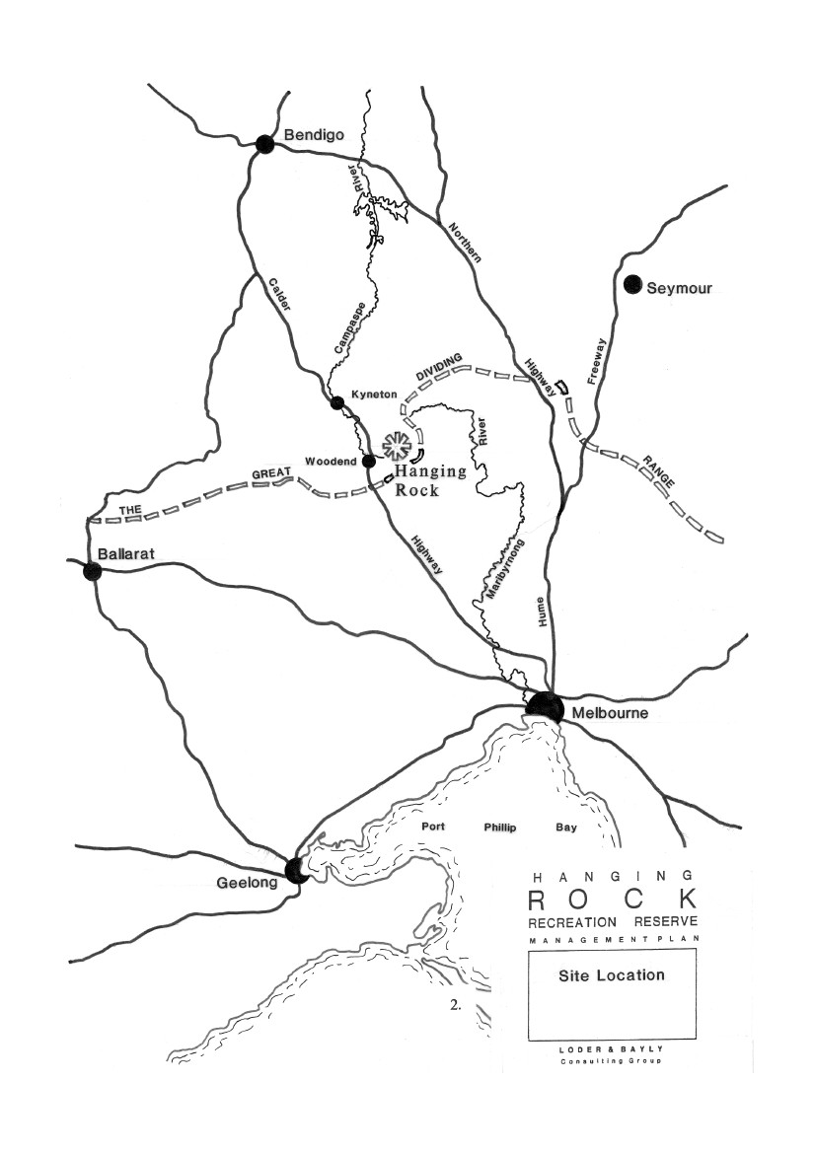

2.
LOCATION AND CONTEXT
Hanging Rock Recreation Reserve is located in a rural farmland
setting approximately 80km N.N.W of Melbourne, generally one hour
drive. It is 7km E.N.E. of Woodend, accessed by the Calder Highway
and roughly half way between Melbourne and Bendigo.
To the south of the Rock, the Macedon Ranges run East to West, with
their most prominent points, the Camel's Hump and Mt. Macedon
easily seen from the Rock Reserve. To the north-east the Cobaw
Range runs parallel with the Macedon Ranges, providing a forested
background to the rural areas surrounding the Rock.
The surrounding area is mainly cleared, undulating grazing land with
some cropping. Being reasonably close to Melbourne, the area has
seen an increase in commuter residents and the resultant growth in
hobby farming and small rural residential properties.
The Victorian Tourism Commission and the local tourist authorities
heavily promote the area for day tourists, in conjunction with Mt.
Macedon, (although this has been far less of an emphasis after the
Ash Wednesday bushfires) Gisborne, Woodend, Kyneton etc. The
growth of a high quality wine industry is likely to attract many more
tourists to the district.
3
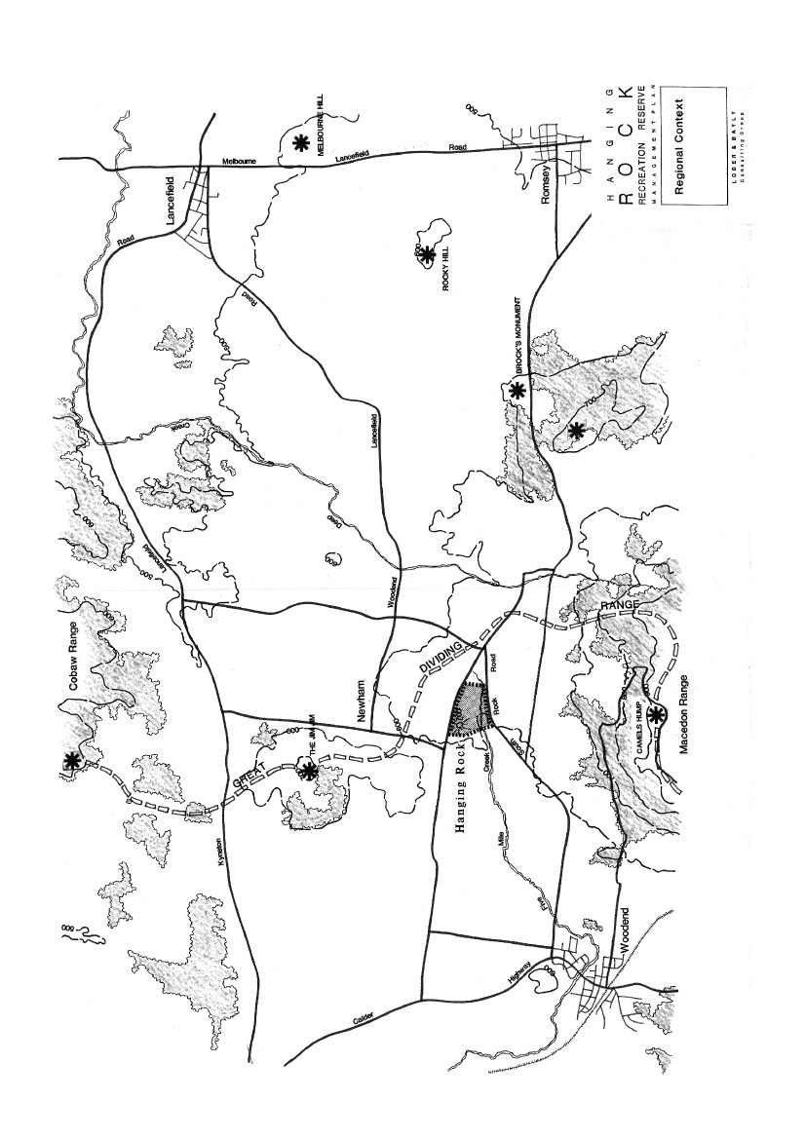

3.
PHYSICAL DESCRIPTION
3.1
THE SITE
The Hanging Rock Recreation Reserve is now comprised of two
distinct areas. The first area, the original reserve, is 66 hectares in area
and is comprised of the Rock, racecourse and picnic areas. The
second area of 22ha is the newly acquired property to the east which
is almost entirely treeless, having been used for grazing purposes.
The Rock and its surrounding bushland is located near the
north-western boundaries of the reserve, the rock itself covering
approx. 9 hectares and its summit of 711 m A.H.D. jutting 100 metres
above the surrounding plain.
Five mile creek, a tributary of the Campaspe River, flows from east to
west through the southern portion of the site, filling 3 dams in the
process. Little more than an open channel drain in its central stretch,
the creek stops flowing in the drier months. A water reserve at the
point where the creek enters the property from the east has more of an
overgrown/semi-natural feel.
The racetrack, located in the north-eastern corner close to and parallel
to the eastern boundary, takes up a very large proportion of the
reserve.
Detail about specific site characteristics follows.
3.2
SOILS AND GEOLOGY
Hanging Rock is a 100 metre high volcanic mamelon lying on the
time boundary between the older volcanics and a newer series. It is
part of an area with affinities with other volcanic provinces in N.S.W.
and Queensland and it has resulted from a process of Lava
differentiation that is restricted to two small areas of Victoria, those
two being Gisboume/Woodend and Daylesford.
On eruption approximately 6 million years ago, small volumes of
silica rich soda-trachyte lava were produced. Hanging Rock is the
only recorded location of this rock in Australia. The Lava was of a
higher viscosity than most, and the greater resistance to flow caused a
dome to form around the point of eruption, on cooling producing a
steep
5
sided, fractured mass which has been exaggerated by weathering to
produce the rock as we know it today.
During the initial weathering process, a solution rose to the surface to
form an erosion resistant crust. Where the crust has been disturbed,
the erosion process has been accelerated. As a generalisation sods are
deepest where the vegetation is most substantial, these areas being the
central area forest and around the base of the Rock.
The local soils are moderately fertile with those derived from the
soda-trachyte being less so with lower levels of Phosphorus and
Calcium.
3.3
CLIMATE
The climate is fairly typical of inland cool temperate areas with cool
wet winters and warm/hot dry summers. Climate data for Kyneton, 14
kms to the north-west follows:
RAINFALL
Mean monthly
-
Highest
Lowest
-
-
Jun 90mm
Jan 38mm
TEMPERATURE
Mean max
Mean min
3.4
-
-
-
-
Lowest
Highest
Lowest
Highest
-
-
-
-
Jul 10°C
Jan 26°C
Jul 20°C
Feb 10.5°C
VEGETATION
The vegetation of the Hanging Rock Reserve constitutes one of the
few remnant pockets on the plain between the Macedon and Cobaw
Ranges and it is of great importance as it forms part of a movement
corridor for indigenous fauna.
The least disturbed parts of the site are the foot slopes to the Rock,
and the native grasslands inside the racecourse. The grassland is in
good condition and is floristically the most important plant
community in the reserve. The next least disturbed area are the
boundaries to the north-east and south-west. The remainder of the site
is heavily disturbed, particularly the area each side of the entry drive
and the
6
racecourse. The newly acquired property is an almost completely
treeless field of long pasture grass.
The Rock vegetation is typified by scattered and slightly stunted trees
and shrubs growing between the boulders, with the central forest area
with its deeper soils and protected aspect being an exception to this.
The upper slopes of the Rock are highly exposed, dry and the soils
shallow. Species found here include Eucalyptus pauciflora, and
Eucalyptus rubida, Exocarpus cuppressiformis and Acacia dealbata.
The mid slopes and central forest area with their deeper sods and
increased run-off retention are able to promote a greater variety and
density of vegetation. Species found here include Eucalyptus rubida,
E. Radiata, Acacia dealbata, A. melanoxylon, Exocarpus
cuppressiformis and Pomaderris aspera. The upper limit of bracken,
Pteridium esculentum is found here.
The footslopes and flats around the rock are more fertile, have a
greater depth of soil and higher and more consistent moisture levels.
The density of vegetation is greater on the south-side of the rock than
the north side due to it being shaded and therefore moister, although
the vegetation variety is greater on the north side where more annual
species are encountered especially in spring and summer. Typical
species include: Eucalyptus radiata, E. rubida, E. ovata, E. obliqua, E.
viminalis, Acacia dealbata, A. melanoxylon, A. mearnsii, Pomaderris
aspera, and Cassinia s.p. Bracken is at its densest around the base of
the rock and on the lower slopes.
The grassland to the north of the centre of the race track is an example
of remnant native grassland that would have existed in the area prior
to European settlement. Major species present include Themeda
triandra and Danthonia sp. This grassland is worthy of protection due
to its relative scarcity and is considered to be of national significance.
The main southern entry drive is lined by an avenue of exotic tree
species – Cupressus macrocarpa "lambertiana" aurea and Populus
canescens.
The main carpark has a variety of Eualyptus species planted in rows
between the bays, some of these being: Eucalyptus globulus, E.
cinerea, Acacia bailyana.
Recent plantings in the area of the creek flat have tended to include a
greater use of indigenous species.
A list of flora is included in the appendix.
7
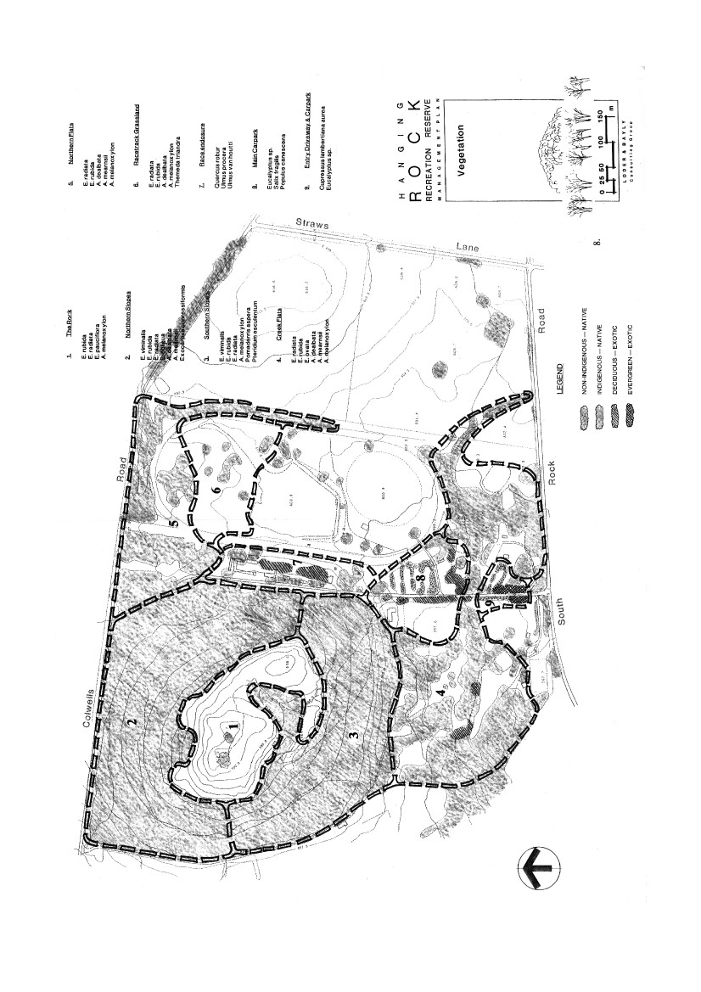

3.5
FAUNA
For such a relatively small area, and one that is subject to such visitor
pressure, the Reserve is a well endowed with wildlife. The most
notable, and the one most sought by tourists, is the Koala, a dozen of
which live in the more heavily vegetated and undisturbed areas.
Released Wallabys used to live within the reserve but these were
attacked and killed by dogs prior to the current protective fence being
erected.
The reserve is valuable as a wildlife corridor, as it forms part of a link
between the Macedon and Cobaw Ranges and is a refuge for species
such as the Black Wallaby. It is also important as a transit area for
migratory birds.
The dam in the centre of the racecourse and the nearby mature and
dead trees form an important bird habitat area.
A list of fauna present in the reserve is included in the appendix.
9
4.
HISTORY
ABORIGINAL
Hanging Rock is located on what was the north western boundary of
the Wurundjeri tribal area. It does not appear to have had any spiritual
significance other than it being a "special" place for the Wurundjeri,
but any future development should be undertaken in consultation with
the Victorian Archaeological Survey.
Archaeological surveys, particularly the discovery of Keilor Man,
date an established human presence in the approximate area 36,000
years ago.
EUROPEAN
In 1836 Major Thomas Livingston Mitchell on a journey that would
lead to the opening up of the Port Phillip District gave the Rock its
official name, Mount Diogenes, in keeping with historical Greek
names he gave other areas in the district.
In 1837, settler Edward Dryden established a squatters run in the area
and for a while "the rock" was named Dryden's Rock after him. 1857
saw a high demand for land in the area with the larger squatter's runs
being sub-divided into smaller farms. William Adams purchased the
farm surrounding the Rock and, realizing its potential as a tourist
attraction, set about developing it as a resort. A dam across Five Mile
Creek created a lake of about a hectare in area which was stocked
with swans and other waterbirds. Exotic plants were introduced to
give the area a European flavour.
A carriage track was constructed running to the flat area above the
Southern line of pinnacles and in 1877 a racecourse was laid out on
the western side of the rock.
In 1884 the property was purchased by the Victorian Government,
added to an existing water reserve to the east of the Rock and named
Hanging Rock Recreation Reserve. The Reserve was then placed
under the control of the local Council as Committee of Management
appointed by the Minister for Lands.
In 1885 the Hanging Rock race club was formed and the racecourse
laid out in its current location in 1909.
10
The Rock is said to have been used as a look-out by at least two
Bushrangers, McDonald and the more infamous Dan "Mad Dog"
Morgan.
"Hanging Rock" was a name given to a formation over the path at the
top of the stairway where a large boulder is wedged between two
vertical columns.
The Reserve was managed by the Council of Newham and Woodend
until 1959 when three members of the Hanging Rock Race Club were
added to the Committee of Management. The management of the
reserve reverted to council in 1990.
Joan Lindsay's book "Picnic at Hanging Rock" published in 1967 and
the film based on the book, first screened in 1975 both heavily
publicized the Rock and led to increased visitation.
11
5.
SITE ANALYSIS
5.1
VIEWS TO THE ROCK
The first glimpses the tourist gains of "the Rock" are from the
distance on the approach roads from Woodend, Newham and
Macedon. The closer one gets to the entry off South Rock Road, less
of "the Rock" is visible as it is hidden by the concentration of
vegetation in the immediate vicinity. Once within the boundaries of
the reserve, the best views are from the small hill to the east, located
on the recently purchased property, where the Rock can be seen rising
above its skirting vegetation. There are also excellent views from this
hill down the valley toward Woodend.
5.2
VIEWS FROM THE ROCK
Given its elevation of some 100 metres above the surrounding plain,
the views are, as could be expected, quite superb, being spoilt only by
the short distance views to the west of the rural residential subdivision
at the foot of "the Rock".
To the south is the Camel's Hump and the Macedon Ranges, to the
North, the Jim Jim and Cobaw Range. From the eastern edge of the
summit, the views over the reserve and racecourse are breath taking,
with the racecourse buildings almost entirely hidden from view at the
foot of "the Rock".
5.3
INTERNAL VIEWS
The semi-vegetated riverflats form a pleasant backdrop to views from
the entry road, particularly where they form a partial visual enclosure
to the play meadows.
The actual creek is unattractive, drain-like and weed infested,
particularly in the section to the south of the racetrack.
Carparking areas to the south of the rock are bare, eroded and visually
intrusive. The access road to these carparks and the connection to the
northern picnic areas crowd the bottom of the rock intruding on the
natural resources.
12
Many structures over the site, particularly the toilet blocks and
corrugated fences and iron sheds of the racecourse, detract from the
visitor experience and should be removed or renovated.
13
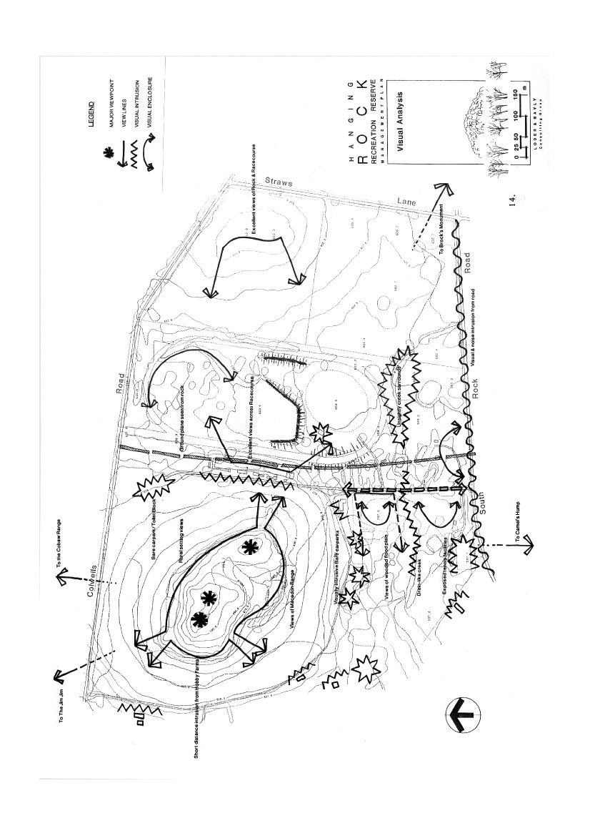

6.
OPPORTUNITIES AND
CONSTRAINTS
The preceding analysis of the sites content, history and natural,
physical and perceptual components reveals the various opportunities
and constraints pertaining to the site in terms of its future use and
management. The following tables outline the sites opportunities and
constraints:
15

OPPORTUNITIES AND CONSTRAINTS
CONSTRAINTS Past zoning has allowed development at an undesirable
density to encroach on site - minimal or no buffer.
Contextual
Historical

Historical use of the site by the race club has meant thatmuch of the site has been alienated.
Physical

Current rock access system is congested on busy days.Creek flat area is flood prone with a low carryingcapacity in winter.Race track buildings enclosure and track fence alienatelarge areas of land from public.
Physicalcontinued
OPPORTUNITIES A resource of national geological significance in such close
proximity to Melbourne.
Within a short distance to other tourism features in the area
e.g. Mt. Macedon.
Current zoning will ensure rural setting remains intact. Opportunity to promote to tourists based on past cultural
events
such as picnic race meeting and the book and film "Picnic at
Hanging Rock".
Opportunity to provide interpretation based on geological
and cultural history.
Purchase of "22 ha" allows significant restructuring to take
away picnicking pressure from close to rock and morenatural environments.
Surrounding road system could double as the reserves
circulation system.
Opportunity for increased use of existing racecourse
facilities by public.
Kiosk located in prime position for up-grading. Toilet blocks are structurally sound and could be retained
and renovated.
Dam in centre of race track could be developed with board
walks and jetties.

Shape of race track blocks movement into new propertyfrom west to east.Race track location squeezes movement north-southbetween itself and base of rock.New property virtually treeless and won't be suitable forrelocating picnic activities for a considerable time.Current access fee collection system means Ranger isinhibited from undertaking other tasks.Roads outside kiosk make it a user "unfriendly" location.

Natural
OPPORTUNITIES Opportunity to increase habitat value of reserve by linking
bushland from Rock to surrounding area, making it moreinviting to roosting birds etc.
The race track has protected a natural grassland area in the
centre from trampling.
The creek has the potential to be re-shaped with ponds and
wetlands along it.
Less disturbed parts of the reserves vegetation may be
suitably restored as quality bushland.
Regular burning has aided Themeda grassland regeneration
Perceptual

Hill on new property has excellent views of rock and has thepotential to be developed as an activity node.
CONSTRAINTS Current rock climbing access to the base of rock is causing damage to vegetation. Rock climbing may disturb nesting birds e.g. Wedge-Tail
Eagle
Riverflat area poorly drained. Dam in middle of race track used for irrigating track - not
a source of permanent water for fauna.
High numbers of tourists can create erosion on highly
erodible rock summit and sideslopes.
Quality of water in creek is uncertain due to possible
effluent run-off from septic tanks on site.
Weeds are a problem along creek. Creek is moderately eroded Lack of creek flow over summer. Rigorous fire prevention measures such as burning-off
and fire tracks impact on habitat and flora regeneration.
Boundary roads to north-east, east and south are visually
intrusive.
Large numbers of visitors using Rock access stairs cause
congestion and therefore loss of experience.
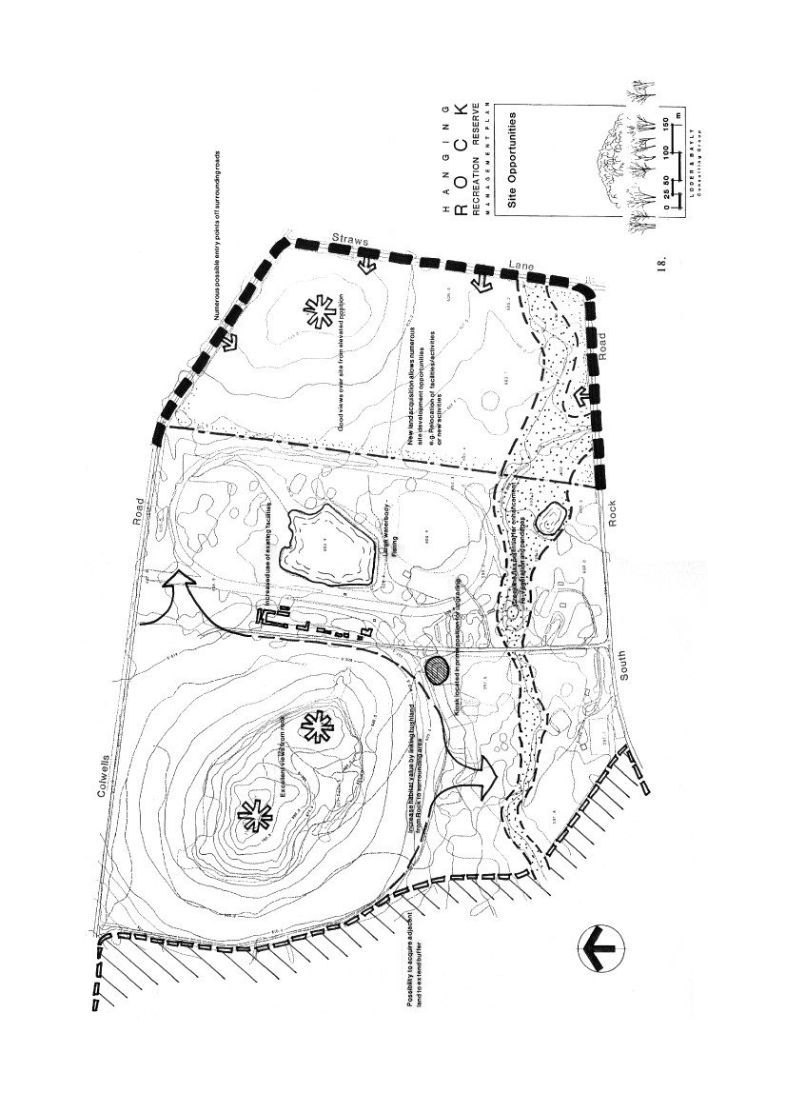
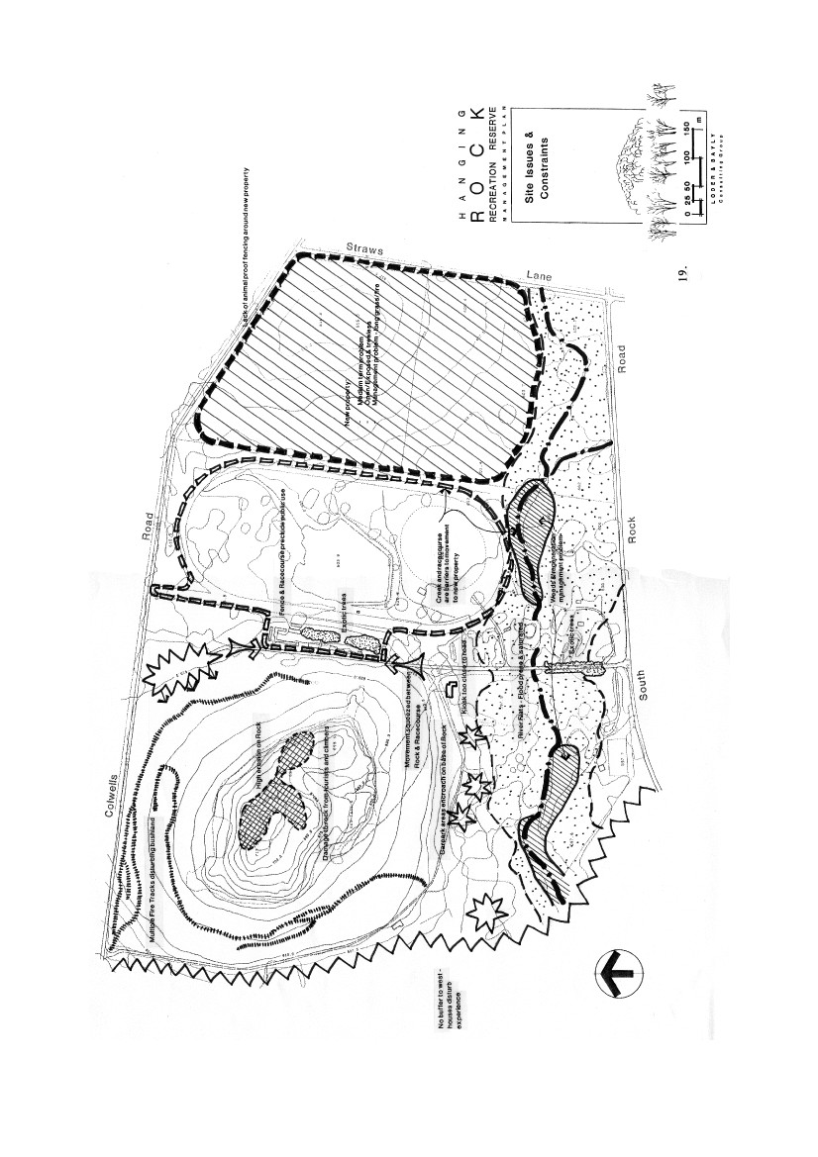

7.
VISITOR SURVEY
7.1
INTRODUCTION
The survey was conducted for 7 days, commencing on Saturday 18th
January 1992 and finishing on Friday 24th January 1992 (just before
the Australia Day Races).
Questionnaires were handed to drivers of vehicles by the park ranger,
as the vehicles entered the park. One questionnaire was handed to
drivers of buses to fill out on behalf of the passengers.
Visitors were asked to complete the questionnaire and place it in one
of the boxes provided before they left the park that day.
Posters at strategic locations in the park reminded visitors to complete
the questionnaire.
Several hundred questionnaires were handed out and a total of 238
usable questionnaires were returned. A copy of the questionnaire is
included in the Appendix.
As it was entirely at the discretion of the visitor whether or not they
returned the questionnaire, the responses obtained cannot be regarded
as statistically representative of the total visitor population. They
provide instead an indicative picture of the type of visitor, why they
come to the park what they do there and improvements they would
like to see.
7.2

ANALYSIS OF RESULTS
The weekend is the most popular time to visit the park
(despite the fact that the survey took place in school
holidays).
Monday
Tuesday
Wednesday
Thursday
Friday
Saturday
Sunday
(No reply by 16)
14
16
13
18
45
55
61
replies
"
"
"
"
"
"
20
Cars represented the most frequent form of travel to the park,
although 10 buses were recorded in the sample.
Car
Bus
Bicycle
Other/No answer
224
10
2
2
(94%)
(4%)
The cars accounted for 1,027 visitors – this represents an average car
occupancy rate of 4.5 people. The 10 buses accounted for 164 people,
an average of 16 per bus, although actual numbers ranged from less
than 10 to 30 people per bus.

A large spread of ages was contained in the sample, as
follows:
0-4years
5-17"
18-24"
25-45"
46-60"
Over 60"
48
320
165
403
154
118
(4%)
(26%)
(14%)
(33%)
(13%)
(10%)
Visitors by bus tended to be older, on average, with a significant
number being over 60.
0- 4years
5-17"
18-25"
26-45"
46-60"
Over 60"

1
30
15
18
36
64
(1%)
(18%)
(9%)
(11%)
(22%)
(39%)
A large number of visitors by car and by bus came from both
overseas and other parts of Australia.
Came by car/bicycle from:
Local area
Melbourne Metro area
United Kingdom
Other overseas
Sydney
Other NSW
Brisbane
Other Qld.
Tasmania
34
104
20
3
5
6
5
5
6
(15%)
(46%)
(9%)
( 1%)
(2%)
(2%)
(2%)
(2%)
(2%)
21
Adelaide
Other S. A.
Perth/Western Australia
Bendigo/Ballarat
Other Victorian
Other Australian
7
4
9
7
11
2
(3%)
(2%)
(4%)
(3%)
(5%)
( 1%)
Note: Some interstate/overseas visitors were brought by
Melbourne residents.
Came by bus from:
Europe/America/Australia
Darwin/England
Australia Wide
Adelaide
Perth
Melbourne Metro area
2
1
2
1
1
3
Most people (other than those living locally) were visiting the
area as part of a day trip or passing through the area as part of
an extended trip.
On a day trip
Staying in local area
Passing through as part of an extended trip
152
38
48
(64%)
(16%)
(20%)
About half the sample were spending less than half a day at
the reserve – the same was true for bus visitors.
Spending all/most of day at reserve
Spending half a day at reserve
Spending less than half a day at reserve
35
83
119
(15%)
(35%)
(50%)
Many different activities were undertaken during the visit to
the Reserve - with a large percentage of the sample going up
the rock.
Climbing/going up Rock
Walking around
Sightseeing
Picnicking/BBQ
Relaxing
Social- with family/friends
Nature study
Informal games/ball games
Formal sport
198
152
147
125
112
69
34
22
2
(83%)
(63%)
(62%)
(53%)
(47%)
(29%)
(14%)
(9%)
1%)
22

Note: Multiple answers.

Clearly the desire to climb and/or see the rock and visit the
area made famous by the book and the film are the main
reasons for coming to Hanging Rock Reserve (rather than
some other place). Main reasons are shown in detail below:
Main Reasons for Coming To-day
To see/Climb rock/Hanging Rock38
The film/the movie/to find Miranda,32
"A Picnic at Hanging Rock"/The Book
Recreational activity/something to do/ 29
For enjoyment/Sightseeing
Never been before21
To bring overseas visitor/interstate20
visitor/tourists
Natural bush setting/beautiful spot12
On route back to Melbourne/on tour/11
on way home
Read/heard a lot about it/famous place 10
Place for Picnic/BBQ9
A place to walk and climb/exercise7
Family outing/group outing/nice setting 7
for family outing
Live locally/not far from home6
A days outing8
Close to Melbourne6
Recommended by a friend5
Been before and liked it5
Historical area/part of Australian history 4
Mystery/Adventure3
Other comments17
No answer29
Note: Multiple answers

On ways to improve the area, nearly half the sample had
either no opinion, or felt that the area was good as it is. The
entry fee was mentioned as a problem by a small number of
people.
Improvements to the walking trails, the map/pamphlet and
naming of significant areas on the rock were among some of
the constructive suggestions made. Others were keen to see
the area kept natural and revegetated with native plants, or
native animals and birds encouraged back to the area. The
table below shows details.
23
(16%)
(14%)
(12%)
(9%)
(8%)
(5%)
(5%)
(4%)
(4%)
(3%)
(3%)
(3%)
(3%)
(3%)
(2%)
(2%)
(2%)
(2%)
(7%)
1%)
How to Improve the Area
Don't change it/Nice as it is
No answer
Better walking tracks/less difficult
walking tracks/better signposted
tracks/walking distances and
difficulty defined/colour coded
walking tracks
Reduce/remove entry fee
Naming of locations at sites on rock/
naming locations referred to in
film/book
Better litter control ban bottles
on rock/more bins
Keep it natural/don't develop
More native animals/birds/sanctuary
for native animals/birds/
bring back koalas
Get rid of flies
Childrens play equipment/more for kids
Better pamphlets/more information on
pamphlets/on map
Get rid of ugly sheds/ugly toilets/
ugly wire fences
More BBQs/Electric BBQ's
Improve toilets
Handrails for older/disabled people
Lift/chairlift up rock
Maintenance of existing paths, handrail,
fences/tables
Get rid of Racecourse
Revegetate with native trees/plants/
plant native trees in picnic area
More information about history of the area/
aboriginal history
Swimming area
Refreshments/water at top
Improve area for tourists
Rock impressive but surroundings devastated
Information leaflets on arrival/map on arrival
Modernise/clean-up the shop/better food shop
Other comments
30 (13%)
85 (36%)
20 (8%)
18 (8%)
13 (5%)
11 (4%)
11 (5%)
10 (4%)
6
7
7
6
5
5
5
4
4
4
4
3
3
3
2
2
2
4
10
(3%)
(3%)
(3%)
(3%)
(2%)
(2%)
(2%)
(2%)
(2%)
(2%)
(2%)
( 1%)
(1%)
(1%)
(1%)
(1%)
(1%)
(2%)
(4%)
24
8.
LANDSCAPE MANAGEMENT
UNITS
A site such as the Hanging Rock Recreation Reserve contains a
variety of landscape types and settings, each of which are quite
individual in the way in which they respond to public use and in the
maintenance they require. It is necessary therefore to break the site up
into landscape management units. The objectives for management and
the proposed management actions for each are set out in the following
table as well as a Landuse Strategy/Planning Matrix.
25

OBJECTIVES AND ASSOCIATED ACTIONS FOR LANDSCAPE MANAGEMENT UNITS
PRESCRIBED ACTIONS
VEGETATION/RESTORATION

Remove all weeds and allow natural
regeneration.
Supplement with indigenous specieswhere re-generation will not take placenaturally.
Adopt measures to control future weed
invasion.
Retain dead trees as habitat value
except where of danger to public.
Remove dead or dangerous tree limbs.
Remove weeds along creekline.
Restore indigenous vegetation along
creeklines and around boundaries.
Revegetate picnic area and carpark on
new property.
Picnic areas to be predominately of
open upperstorey with grassedunderstorey regularly mown to 25-50mm.
Adopt weed control measures
appropriate to the specific problemspecies.

Sealed access road with turn
loops at ends. 4m wide for 1way. 6m wide for 2 way roads.
Sealed or gravelled 90° off
road parking bays grouped in 3-4s.

No major concentrated
carparks.
Removable bollards or
barriers. Allow access for majorevent overflow parking.

Park in bays and walk to picnic areas.Vehicles contained by marked bays andvehicle barriers/bollards.

VISITOR MANAGEMENT
Discourage people from using area except
where formed paths are present.
Interpretive trail will aid in directing
pedestrian flow.
BROAD MANAGEMENT
OBJECTIVES
1 Natural Dominant
EROSION CONTROL

VEHICLE ACCESS AND
CARPARKING

None — all located outside of
perimeter,
To maintain and manage as anatural bushland habit andthreatened species habitat area

Fencing is required in somearea to limit access and controldamage. Allow naturalregeneration. Construction ofstairway up rock may berequired in places.
2
Semi-Natural

To provide for passive recreationin an open woodland setting and torestore and rehabilitate creek edgeand surrounds. Will also act as abuffer to the threatened specieshabitat area.
Re-profile Creek banks andstabilize with planting andlocal rock where appropriate.


PRESCRIBED ACTIONS
VEGETATION/RESTORATION

Ensure vehicles don't compact soil
around existing trees by employingappropriate surfacing techniques.

Slowly replace invasive non-
indigenous trees with indigenous,
Only carpark where buses areallowed to park

VISITOR MANAGEMENT
All large buses (not mini-buses) must park here.
Due to formalised nature of area with hardsurfacing, little management will be required.
Signage required to direct to rock and picnicking.
Formalise and harden landscape treatments tocreek edge for increased pressure of use.
BROAD MANAGEMENT
OBJECTIVES
3 Intensive Use Picnic
EROSION CONTROL

To maintain and manage as a highcapacity carpark and centralactivity node.

Indigenous middle and lower
storey plants should be used whereappropriate around carparks andbuildings.
Formalise edging of
carparking areas and sealsurface to reduce dust.
VEHICLE ACCESS AND
CARPARKING

Sealed major entry road andsealed major carpark locatedopposite kiosk.

Construct defined paths to
heavily trafficked areas suchas kiosk and start of RockWalk.

Vehicle access to stables andcourse facilities allowed onlyon race days.
Road open to managementvehicles only and walkers forthe remainder of the year.
Major events parking allowedon oval.

Formalise drainage of
carpark and picnic areas toreduce damage to grasssurface.
Retain Poplars, Cypress Oaks and
Non- indigenous natives.

Allow selective regeneration ofappropriate large tree species thatwill develop large, clean trunks andstill allow views across race track

Race track to have an even grasscover aided by supplementaryirrigation in summer,

4
Racecourse
Picnic areas within race enclosure are to beopened up to general public use - walk in only.
To maintain and manage as a racecourse, for periodic events, casualpicnicking, and the oval for yearround sporting use.
5

To investigate the possibility ofregenerating indigenous grasslandspecies.
To maintain a cut or grazedheight of 200mm.
To reduce cut height in summer to100mm to reduce fire risk.
In the short to medium term fencewith electric fencing and allowcattle to graze on a seasonal basis.
Open Grassland

Oval lawn to be kept cut short.To remove invasive weed species.
Do nothing to encourage use, but don't stop publicaccess.
To maintain and manage asinformal grassland.


PRESCRIBED ACTIONS
VEGETATION/RESTORATION

Remove all weeds and debrisand manage to control futureinvasion,
Allow selected larger treespecies to regenerate which haveclean hunks and allow viewsacross track.
Conduct mosaic burns ofgrassland on a 5 yearly rotationto reduce biomass, increase internodal spaces and encourageregeneration.
Implement an ongoingmonitoring program.
Replant tree and shrub speciesusing appropriate weed/grasssuppressing matting.
Fence with electric fence toexclude cattle. (In short term)
Once upper storey is establishedstart to develop a lower storey.
Once established employ a 6-10year rotation mosaic burn.

No vehicle access allowed.

Public access not encouraged.

VEHICLE ACCESS AND
CARPARKING

No vehicle access allowed.
VISITOR MANAGEMENT
BROAD MANAGEMENTOBJECTIVES6 Open Native Grassland
EROSION CONTROL
To restore and manage as anindigenous grassland.

Current location of race course running raildiscourages public access. No special managementrequired to correct this. Trampling and rubbishdumping and burning to be avoided.

7
Bush Regeneration
To restore and manage as aeucalypt woodland withshrubby understorey.

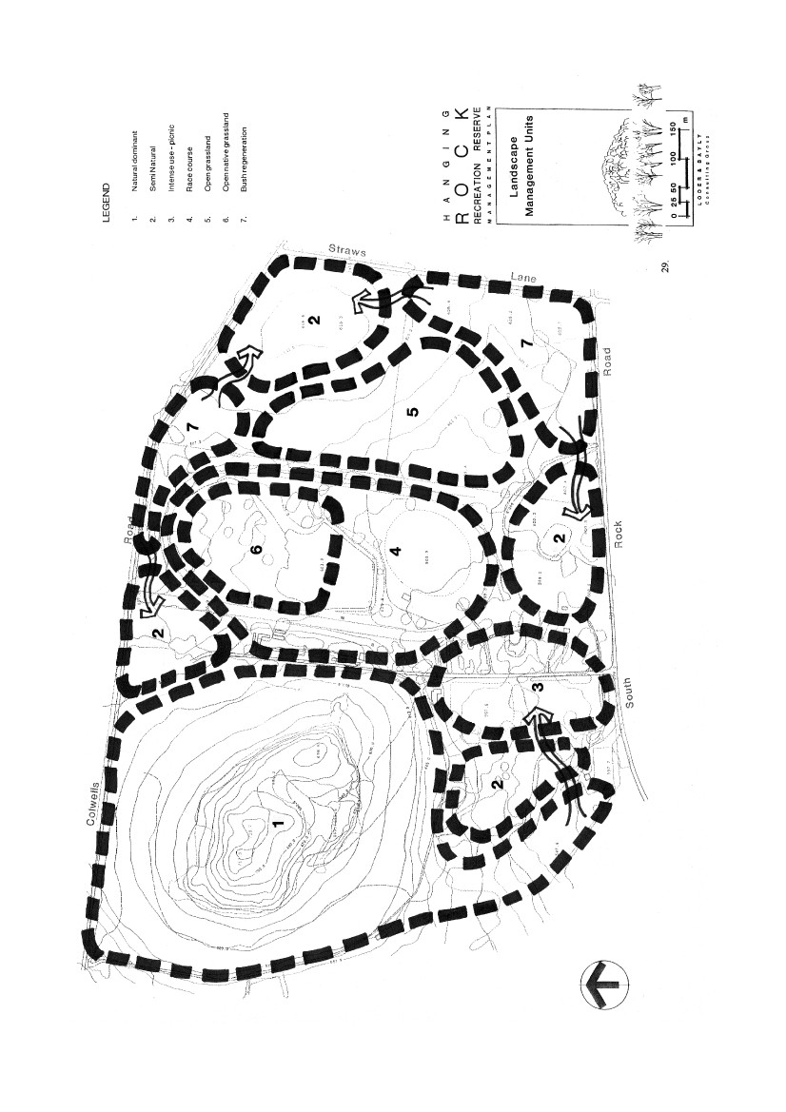

LANDUSE STRATEGY / PLANNING MATRIX
NATURAL DOMINANT & OPEN
SPACE GRASSLAND
some habitat rehabilitation plus changes toincrease carry capacity - essentially amodified ground plane
common but merged with the landscape
all modes to trail heads plus extensive trailnetworks
minor level
high probability of social interaction;occasional peak time overloading
conspicuous control to protectconservation values
SEMI-NATURAL & BUSH
REGENERATION
INTENSE USE PICNIC &
RACECOURSE
some habitat rehabilitation plus significantchanges to maximise carrying capacity
very common and conspicuous
all modes
extensive
other people always present; high level ofsocial interaction; likely peak timeoverloading
possible 24 hour access and control mostlyrelated to health and safety
LandscapeChanges
habitat rehabilitation plus controlledaccess/management devices
Structures
signage & staircases only
Access
pedestrian, education and managementonly
Facilities
NIL
Social
low level contact and managed capacity
Control
controlled access and maximum habitatmanagement
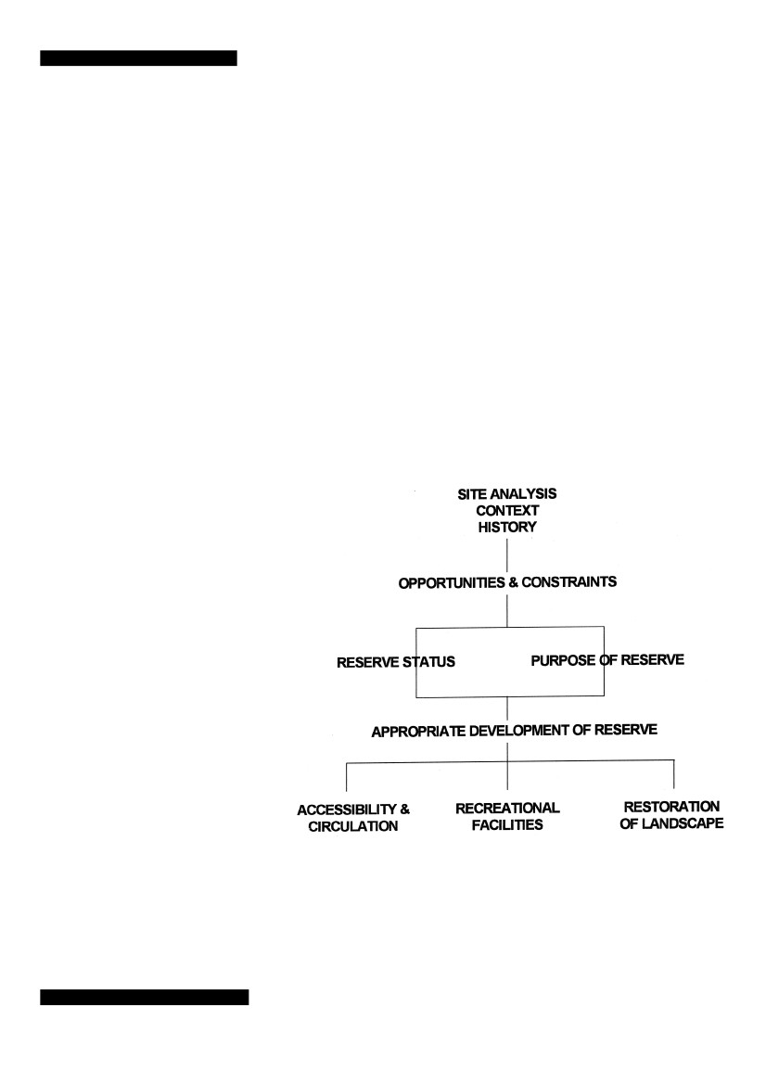
9.
ISSUES IDENTIFICATION
The issues of primary concern in the formulation of an appropriate
management plan for the reserve are listed on the following page.
One of the key issues of Reserve Status, i.e. does it serve local, district
or regional population, has been established by anecdotal evidence as
well as being confirmed by the results of the Visitor Survey. The other
key issue is the purpose of the Reserve, i.e. will the reserve be used
for passive or active recreational pursuits. This has been confirmed by
the L. C. C. Melbourne Area Final Recommendations, that the reserve
is a recreation reserve but that its significant natural values be
protected. In other words, the right of the Hanging Rock Racing Club
to conduct race meetings at the reserve is acknowledged, but the
environment of the rock, its flora, fauna and geological features, must
be protected.
The following chart sets out the issues identification process:
31

ISSUES
ACCESSIBILITY AND CIRCULATION

Control of pedestrian movement around rock.

Weed control

Conflict between rock climbers, and thegeneral public and vegetation and faunaespecially avi-fauna.
Standard design details required for parkfurniture.
Upgrading of site structure, particularly toiletblocks.
Freedom of movement by sporting clubmembers to Tennis and Cricket facilities.
Best use of kiosk and vacant Rangersresidence.
Upgrading of Picnic facilities.
Provision of Playground equipment tocomply with Draft Australian Standards.
Upgrading of creek.
RECREATION ACTIVITIES/FACILITIES
RESTORATION OF LANDSCAPE

Removal or upgrading of existing access roads.

Location of new access roads.

Fee collection and number of entries.

Conflict between fuel reductions, burns/firebreaks and site vegetation restoration.
Should new property be fenced like existing?
Short term management of new property
--
RevegetationGrazing to reduce fire risk
Upgrading of existing carparks and standards fornew ones.

Upgrading of signage - need for standardised sign styles.

Increased area of race day parking spaces.

Any limit to numbers of people on site?

Erosion control
- on rock- high use picnic areas- creekline
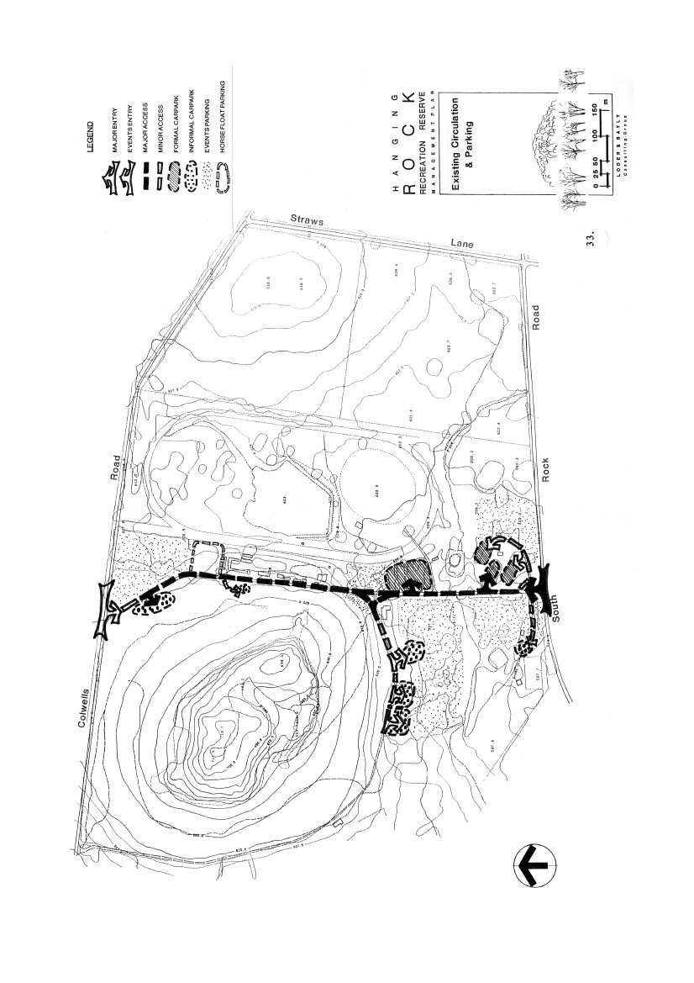
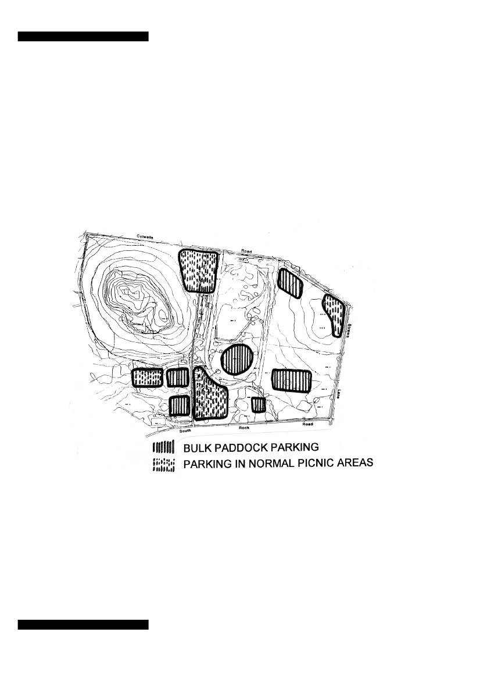
10. SITE CIRCULATION &
ACCESS
This chapter addresses the responses to the emerging issues at the
reserve, particularly those of access and circulation in the light of
opportunities created by the purchase of the new property and existing
constraints around the rock.
Other scenarios were explored but were not considered appropriate.
Major Events Parking
34
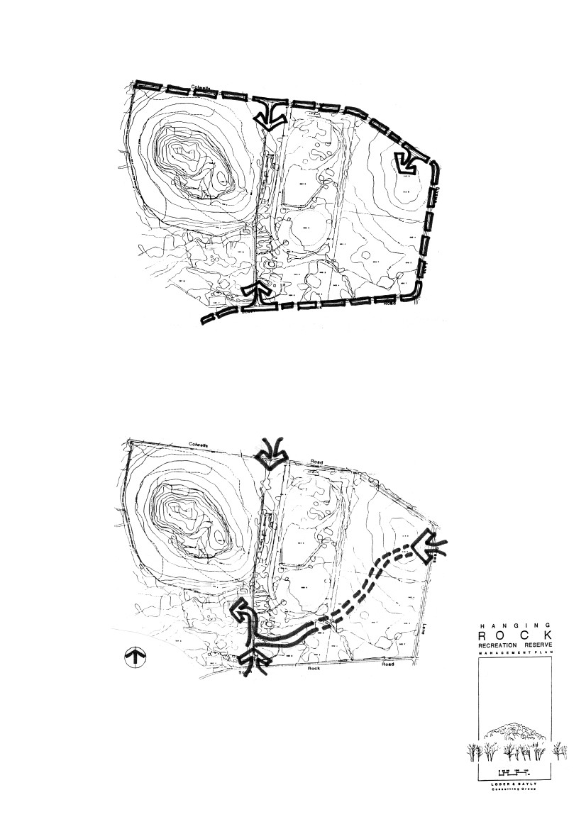
Existing public road system used as the parks
circulation system to access the new property.
Avoids construction of costly roads through the site
although would require money collection at
separate carparking areas.
Possible retain as race day only entry.
Possible picnic area/carpark off Straws Lane.
Main controlled access at existing South Rock
Road entry.
Adoption of Boom Gates at entries may avoid
internal roading.
Access &
Circulation
35
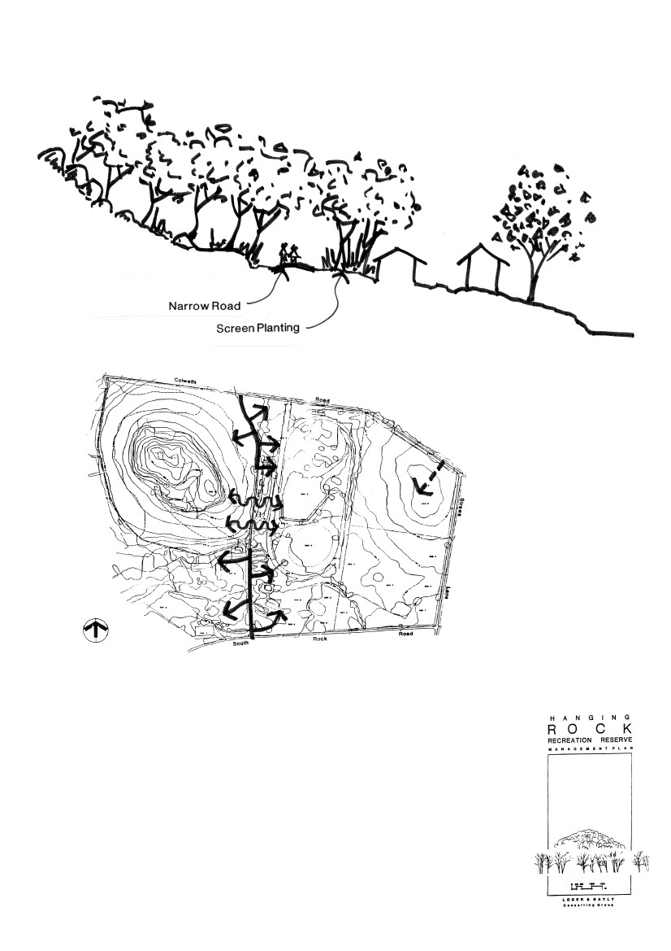
The current north-south road connection
severely cramps the space between the
racecourse buildings and the eastern flank of
"the Rock". This connection shold be broken,
with the road downgraded to a narrowed
walking track/emergency vehicle access.
Indigenous planting would be used to screen
racetrack buildings and to encroach down from
"The Rock" to soften the experience.
Road Closure
Behind Race
Enclosure
36
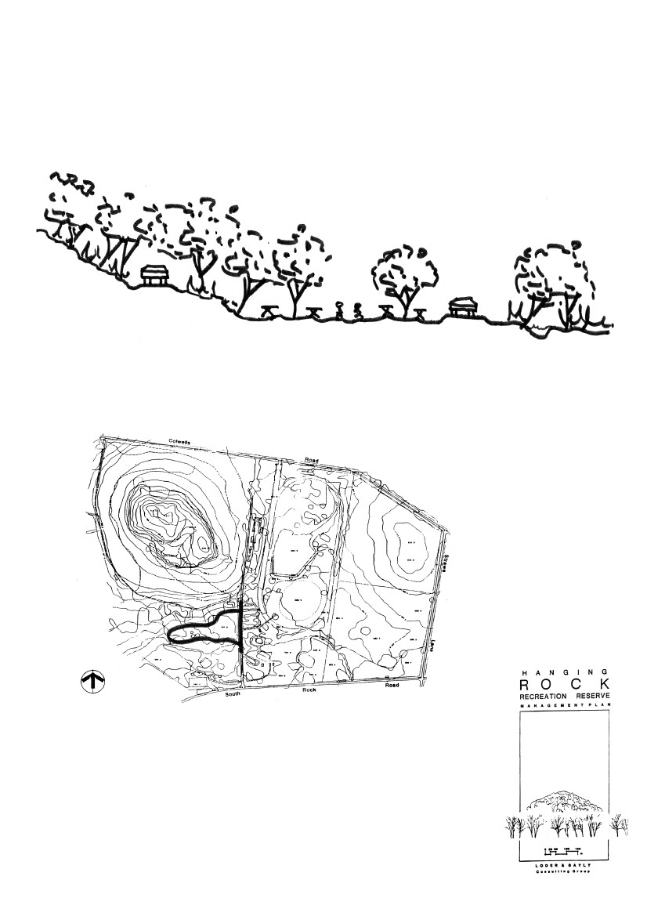
One-way loop track entering along toe of slope and exiting
beside creek would solve the problem of the current road being
too close to the base of the rock.
S.W. Picnic Area
37
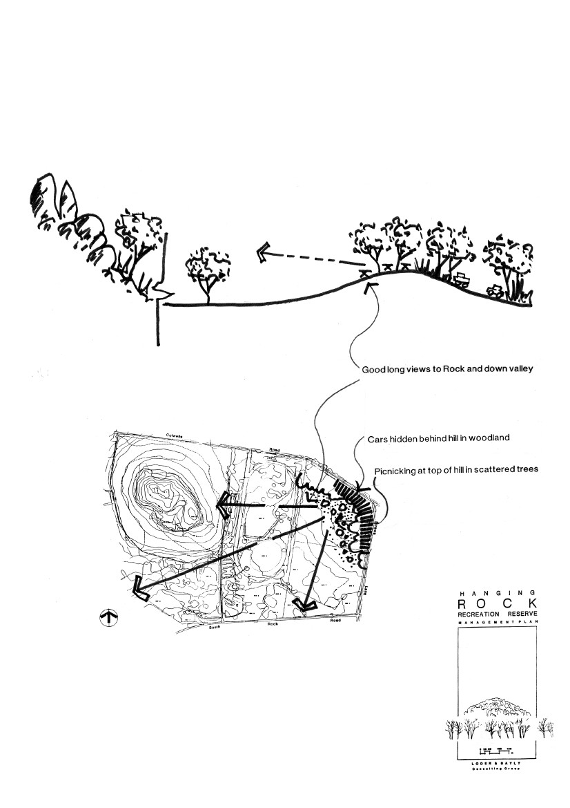
Picnic area developed on the hill in the new
property. The major initial goal is to re-vegetate
this area in order to introduce picnicking as soon
as possible. Cars would be located in trees on the
side of the hill, reducing visual intrusion to view
from "The Rock".
Eastern
Picnic Area
38
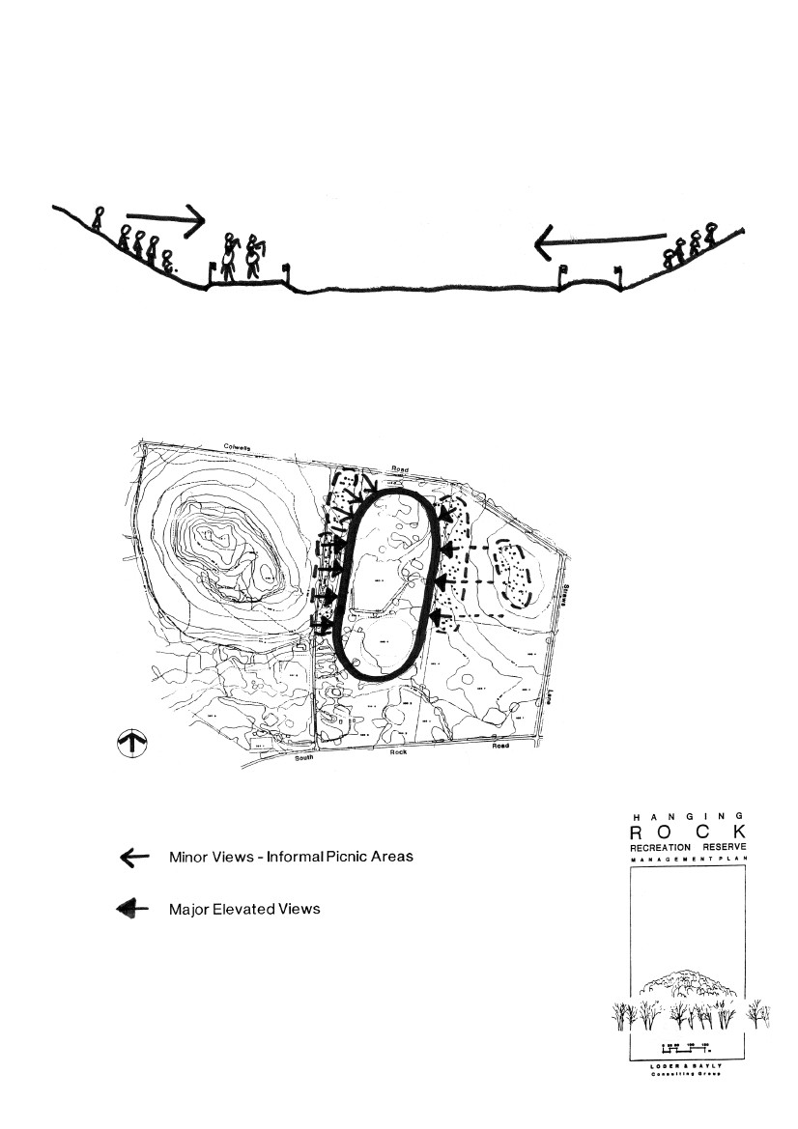
views over track from elevated picnic positions
Race Day Viewing
39
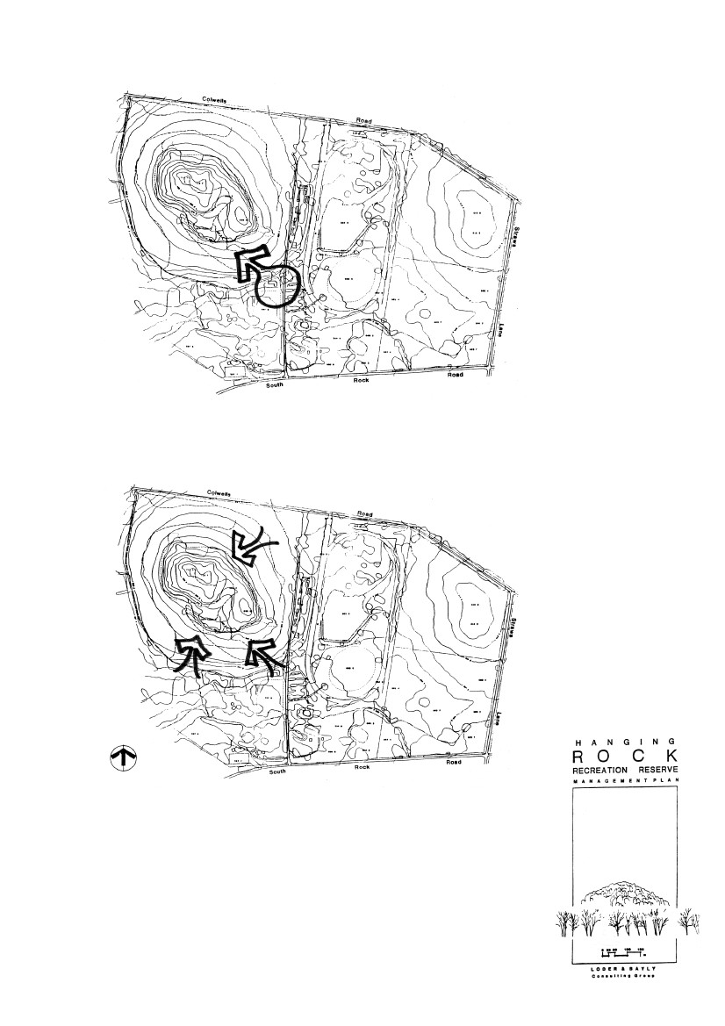
controlled single entry to rock walk through
interpretive centre
multiple entries to rock walk would help to
spread visitor loads away from the stairway,
but would be difficult to control
Access to Rock
40
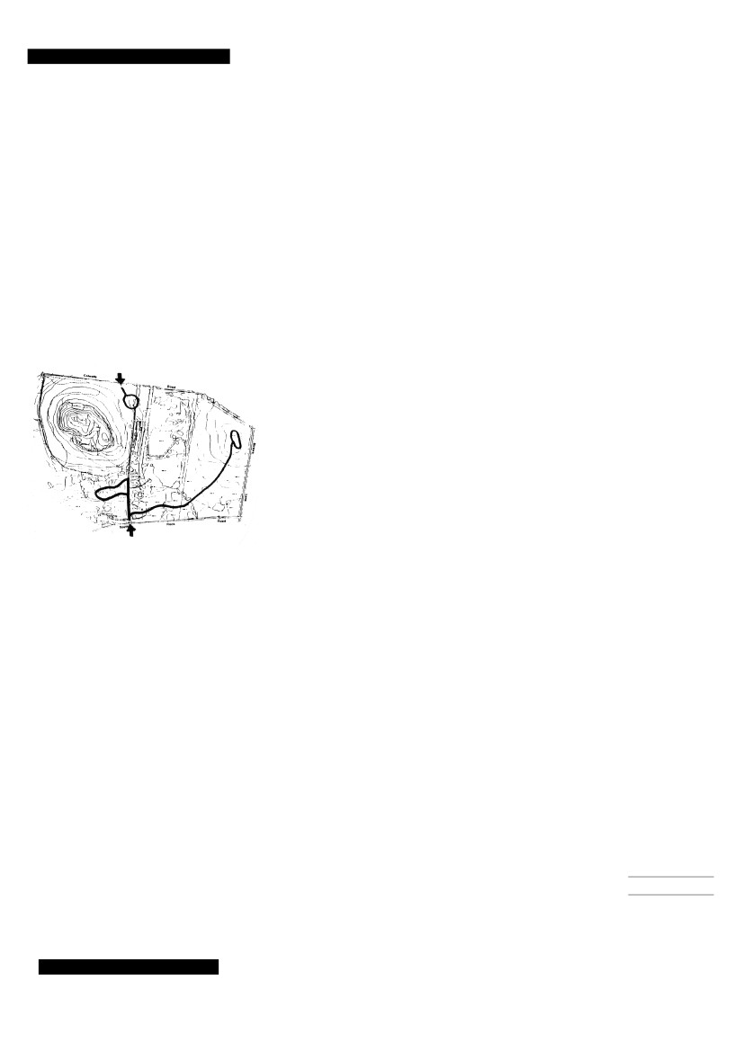
11. REVENUE COLLECTION
AND ACCESS
5 options for revenue collection and access were considered and are
included in the appendix. The preferred option is a modification of
one of these and is outlined below.
11.1
REVENUE COLLECTION AT OUTER PERIMETER
— PREFERRED OPTION
The need to collect an entry fee from visitors greatly affects the
management as well as access and circulation options for the reserve.
An entry fee to access the reserve means that fencing is required
around the entire reserve and money collection points need to be
positioned at every entry. Given the current practice of manning the
gates, this expensive and labour intensive process, potentially limits
the number of entries, increasing internal road costs.
It is possible to make use of access control systems such as
multiple-coin operated boom-gates at the entries, freeing-up staff to go
about other tasks. This system has been applied successfully at the
You Yangs State Park. The all-up cost of a multi-denominational coin
collector and associated entry road works comes to approximately $12
— $15,000, an economically realistic alternative to a rangers wage
spent doing the same thing.
The preferred option proposes retaining the existing 2 entries, but
installing a boom gate at the southern entry. The northern road and
access gate would remain as is, servicing the picnic area to the
north-east of "The Rock" on race days only. A new connection road
could link the eastern riverflat picnic area to the picnic areas on the
hill of the new property in the future as the area is developed.
Boom Gates (including ass. road works)
$15,000 each x 1
Riverflat to Hill access road
650 linear metres x $120/m
Estimated total
$15,000.00
$78,000.00
$93,000.00
41
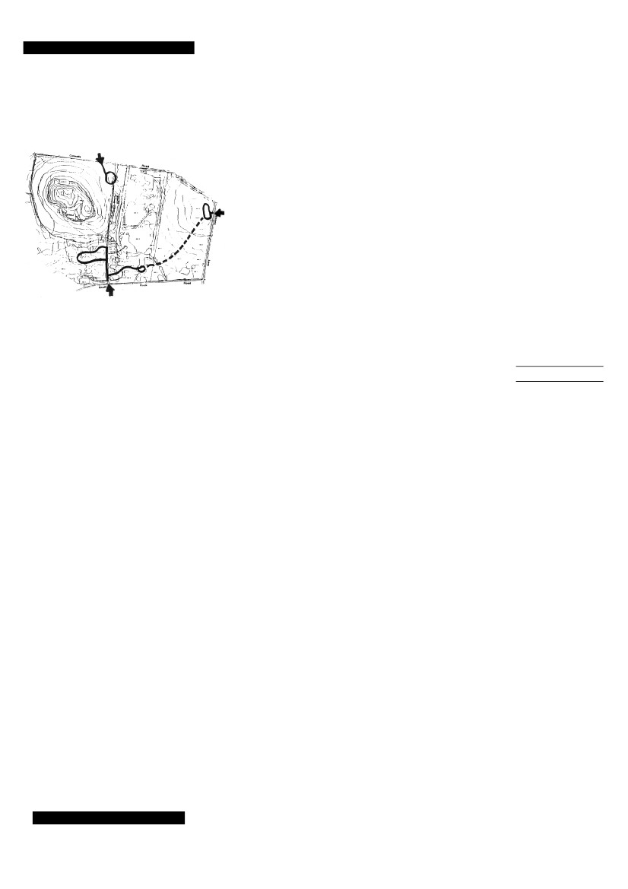
11.2
ALTERNATIVE OPTION
This option proposes 2 entries, one from the south - (for which no new
costing has been calculated as it already exists), accessing the main
picnic area, and a new road coming in from the east off Straws Lane.
This new entry point would access the new picnic area on "the hill"
and could link through the new property to the existing main picnic
areas.
Boom Gates (including ass. road works)
$15,000 each x 2
New carpark for 50 cars at picnic area on
"the hill" and access roading
Optional access road from "the hill" to the
existing main picnic area
650 linear metres x $120/m
Estimated total
$30,000.00
$30,000.00
$78,000.00
$138,000.00
42

